(Approx. 443 words)

LibreOffice 4.4
By Cal Esneault, Former President of CCCC; leader of many Open Source Workshops & SIGs
April 2015 issue, CCCC Computer News
Newsletter (at) clickers.org
www.clickers.org

After Oracle acquired the rights to OpenOffice.org, open-source developers forked it to LibreOffice in 2011. Although many code improvements were made, the user interface remained fairly constant. In the recent release of the ninth major version, LibreOffice 4.4, however, the toolbars for the user interface were significantly rearranged and a variety of new icon themes were included. Below I compare the default "Human" theme from version 4.2 to a few of the new themes from version 4.4 (these are partial views of the Standard and Formatting toolbars from the LibreOffice Writer word processor). Note: themes for 4.4 included and available from the Options menu under View).

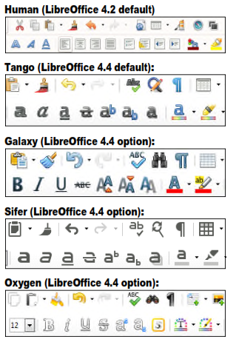
While LibreOffice has always had the capability to read/write Microsoft Office file formats, the cross-compatibility is not exact and usually requires some manual readjustment. One key factor is that Microsoft fonts are proprietary and can't be used unless you are using the Windows operating system. To minimize issues, LibreOffice used defaults of Liberation and Liberation Sans, fonts which corresponded well to the overall size of the MS fonts Times New Roman and Arial (default fonts for MS Office 1997 - 2003). Starting with MS Office 2007, MS Office switched defaults to new fonts -- Cambria and Calibri. To address its own interpretation issues, Google sponsored development of new fonts, Caladea and Carlito, that matched the footprints of the new MS Office fonts. Below are examples of the newer fonts for MS Office and LibreOffice.

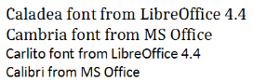

If you are running a Linux OS, you can make LibreOffice automatically replace the MS Fonts with the new open-source fonts (under Options, go to Fonts, and define substitution rules -- for example, Calibri Carlito). This works well for reading the document, but have an original copy with the Microsoft font designations if you edit it and have to send it back to MS Office software.

The above are just two examples of what is a very polished release of LibreOffice. If you need the new version and are a user of long-term support releases of an Ubuntu flavor or a distro based on the Ubuntu code base (such as Linux Mint), you will have to use your search engine to find the appropriate PPA archive and add it your source list for repositories. If you run LibreOffice under a Windows OS, I suggest you remove the current version of LibreOffice, download the new Windows compatible files from the LibreOffice site, and then do a fresh install of the suite to avoid conflicts.

